**CHANDRIKA WOMEN AND YOUTH FOUNDATION**



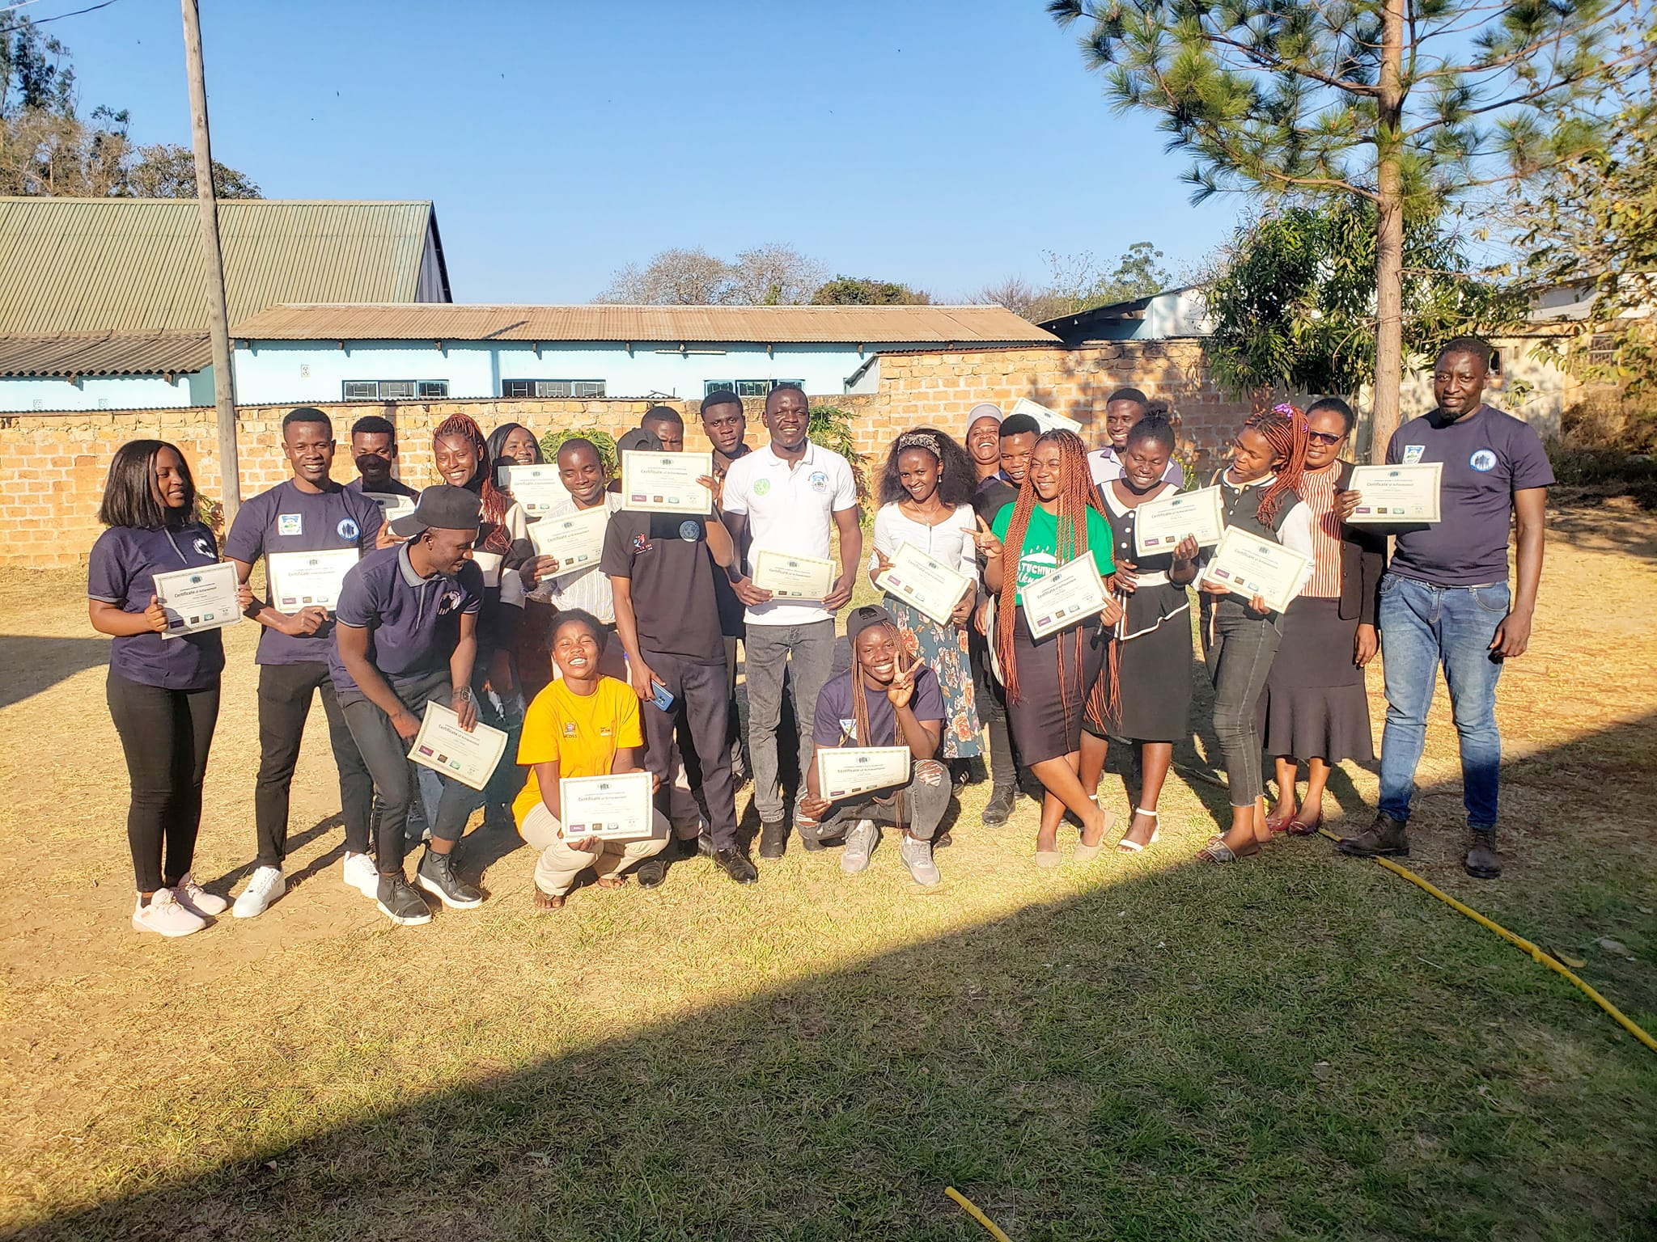

**REPORT ON CLIMATE CHANGE WORKSHOP**

**HELD ON 3RD SEPTEMBER 2024**

**Introduction**

This activity report is based on the Climate Change workshop which was held at Anglican Dioceses (Chandrika Premises) on the 3rd of September 2024. It was attended by a total of 25 participants thus 14 males and 11 females drawn from various organizations and communities such as; Chilyapa Ward, Namwendwe Ward, Mulenshi Ward, CWYF, Forestry Department, Roofus Arts and Human Rights Advocacy Foundation, All for One Initiative, Mansa Municipal Council, ZANIS, CAMFED, African Youth Platform International, Buntungwa Clinic, Sumbu Clinic, Senama Clinic, Chitumbi, Musomali, Care for Nature and Youth Connect Mansa – Luapula Initiative Organisation.

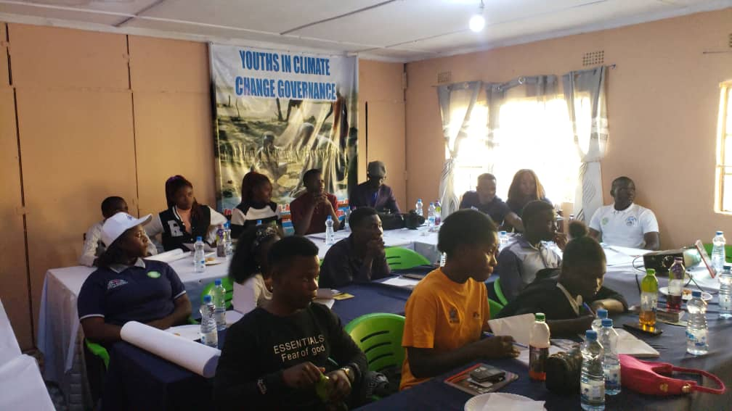***Participants during the Workshop***

**Objective**

To foster a community of young climate change champions, empowered to educate, advocate and take action on environmental sustainability in their respective communities.

**Welcoming Remarks**

The program began at 08:30 am and welcoming remarks were given by the host, the Executive Director for Chandrika Women and Youth Foundation, Mrs Priscilla Chama Mwansa. Thereafter, an engaging, interactive session of introductions, formation of ground rules and workshop expectations took place, allowing participants to get to know each other and state what they were expecting from the workshop. This was followed by an overview of Chandrika Women and Youth Foundation with the purpose of educating the audience on the organisational goals, target audience (groups), thematic areas, and the activities that the organization undertakes.

**Introduction to Climate Change**

The Facilitator informed the workshop participates that “Climate change was one of the most pressing issues of our time, affecting not just our planet but also our daily lives. There is an evident change in our weather patterns, things weren’t this way long ago.”

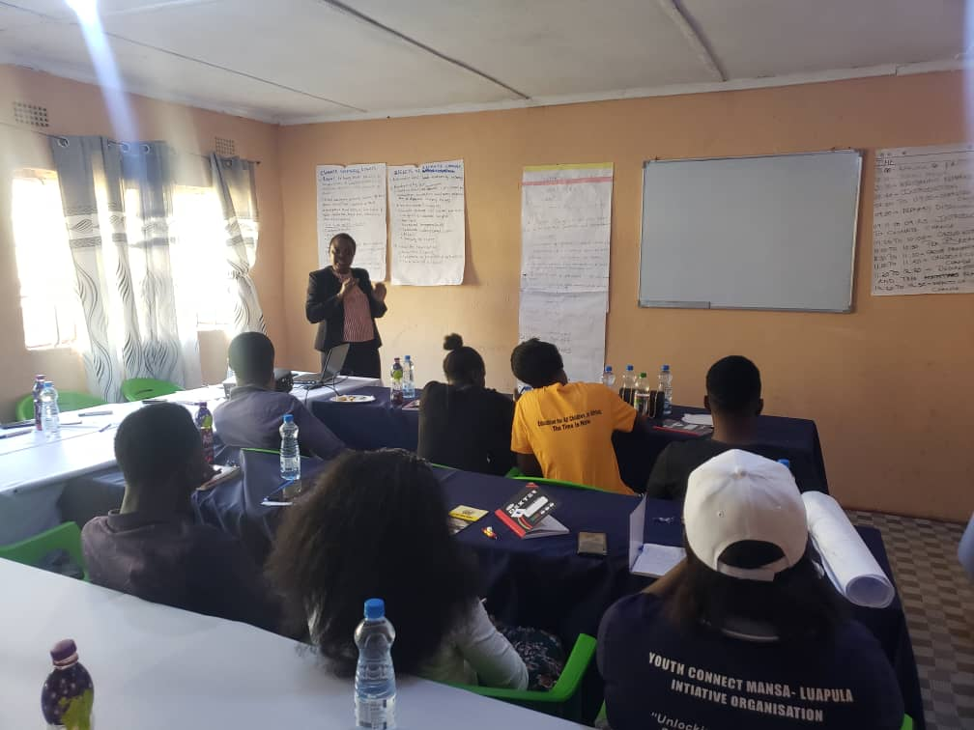***The Facilitator Mrs. Nkunga explaining a point during the workshop***

In order to encourage teamwork, critical thinking and effective communication, the Facilitator from the Department of Forestry, Mrs Nkunga, divided the participants into five groups and assigned tasks for them to discuss, note down key points and select a presenter from each group to share their findings later in the day.

**Group Work**

Participants were tasked to look at the following;

* Group 1: Define Climate Change and its Causes.
* Group 2: What are the Effects of Climate Change?
* Group 3: What are the Impacts of Climate Change?
* Group 4: How can we Prevent Climate Change?
* Group 5: What can we do as youths to get involved in issues of Climate Change?

**Group Presentations**

After group work participants presented their work according to the task that was given to them as stipulated below;

**Group One - Define Climate Change and its Causes**

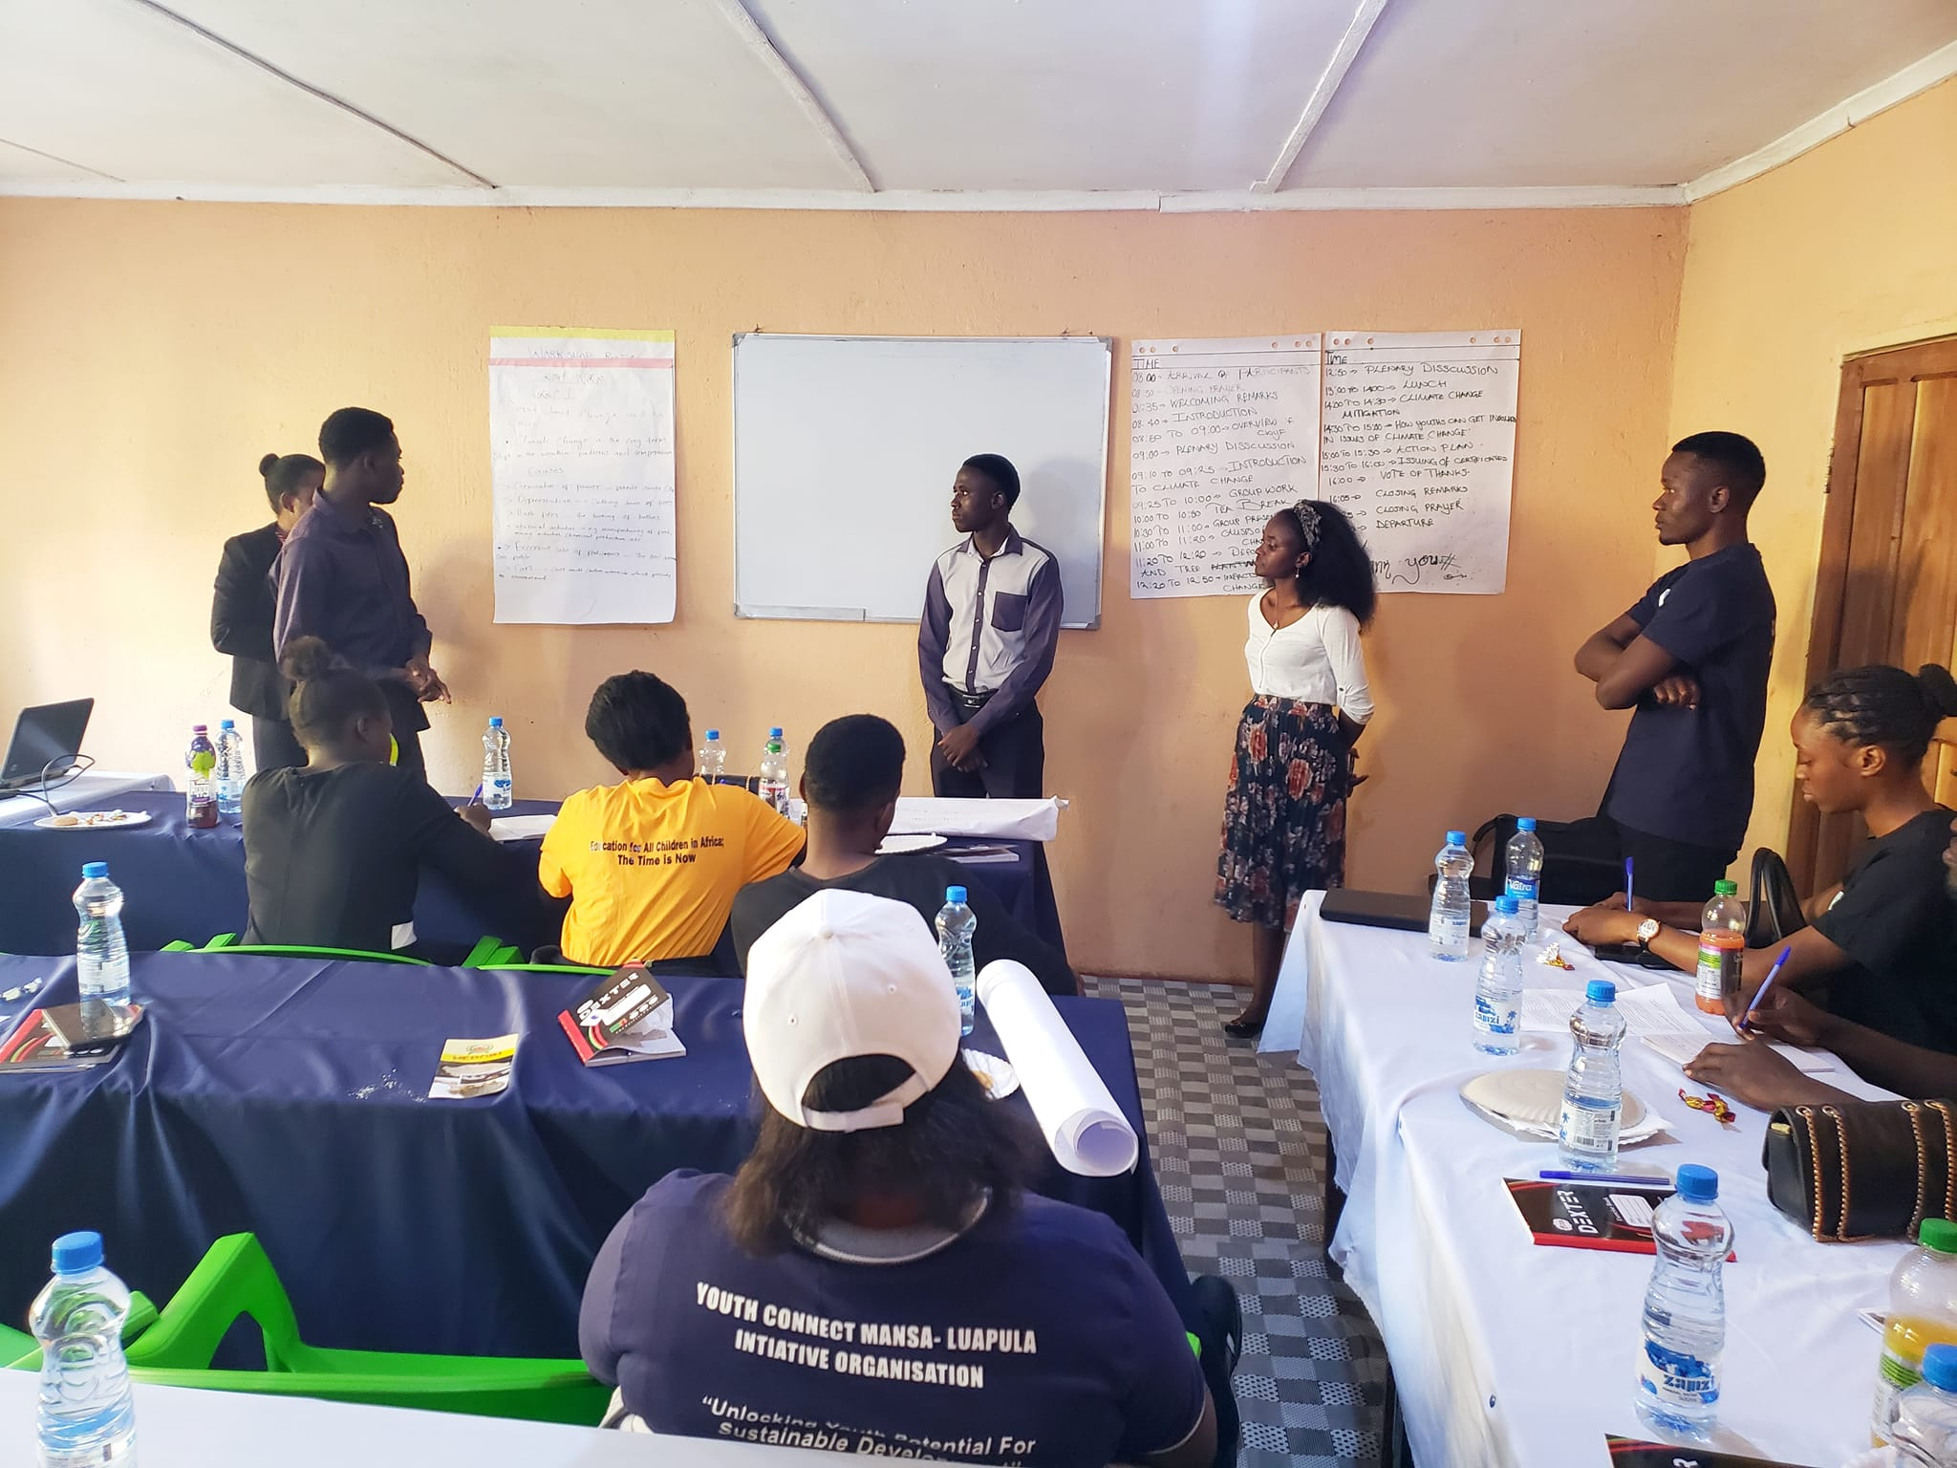Climate change refers to long term shifts in temperatures and weather patterns i.e. conditions becoming wetter, warmer or dryer. Global warming occurs when greenhouse gases (GHGs) collect in the atmosphere and absorb sunlight and solar radiation that has bounced in the atmosphere.

***Group one making their presentation***

* Greenhouse Gases include:
* Carbon dioxide
* Methane
* Nitrous oxide
* Water vapour

The gases trap heat that would otherwise radiate from the planet to outer space. Greenhouse gases help keep the earth warm, however, increased / high concentrations leads to climate change.

**Causes include:**

* Generation of power – foods cause CO2
* Deforestation – cutting down trees
* Bush fires – the burning of bushes
* Industrial activities – e.g. manufacturing of food, mining activities, chemical production etc.
* Cars – cars emit carbon monoxide which pollutes the environment
* Excessive use of fertilizers – the soil becomes less fertile

After group one’s presentation they invited questions from the workshop participants and the following were the contributions from the participants;

***Reactions / Contributions from Participants:***

Mr Bornface: wanted to know how soil erosion contributed to food insecurity?

The response was that there is decreased fertility in the soil. The soil loses its essential nutrients and organic matter making it less productive thus affecting crop yields. There is also decreased water retention leading to increased drought vulnerability.

Mr Mapani a partner from Southern Province contributed by stating that, the fact that Southern Province has long struggled with drought, and Luapula Province is now facing similar conditions, underscores the urgent need to address the root causes of global warming and Climate Change, which are driving these extreme weather events, disrupting ecosystems, and threatening the livelihoods of communities worldwide.

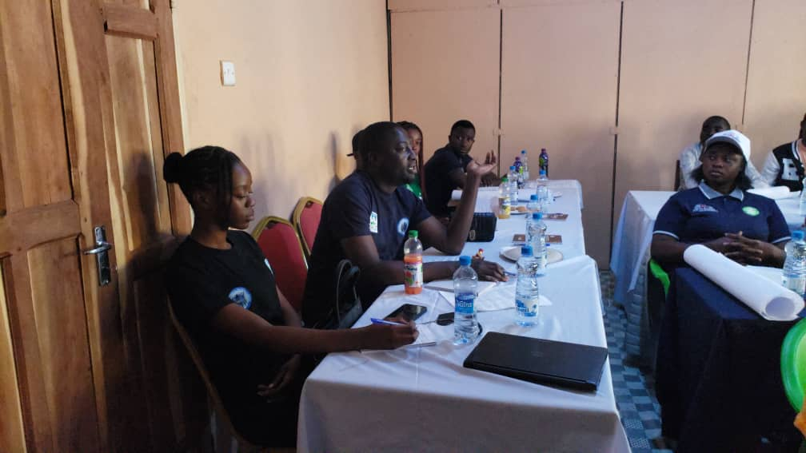***Mr Mapani a partner from Southern Province emphasizing a point***

**Group Two - Effects of Climate Change**

1. Poverty and displacement
2. Economic loss, low economic growth (food insecurity, crime)
3. Destruction of environment can lead to relocation, mutation and even extinction of different living things
4. Environmental impacts (biodiversity loss)

* Climate change and global warming
* Droughts (bush fires) and reduced rainfall
* Poor soils
* Increased (hotter) temperatures
* Reduced underground water
* Floods
* Drying of rivers

1. Health implications

* Zoonotic diseases
* Increase in parasites and pathogens
* Skin related ailments

1. Divorce
2. 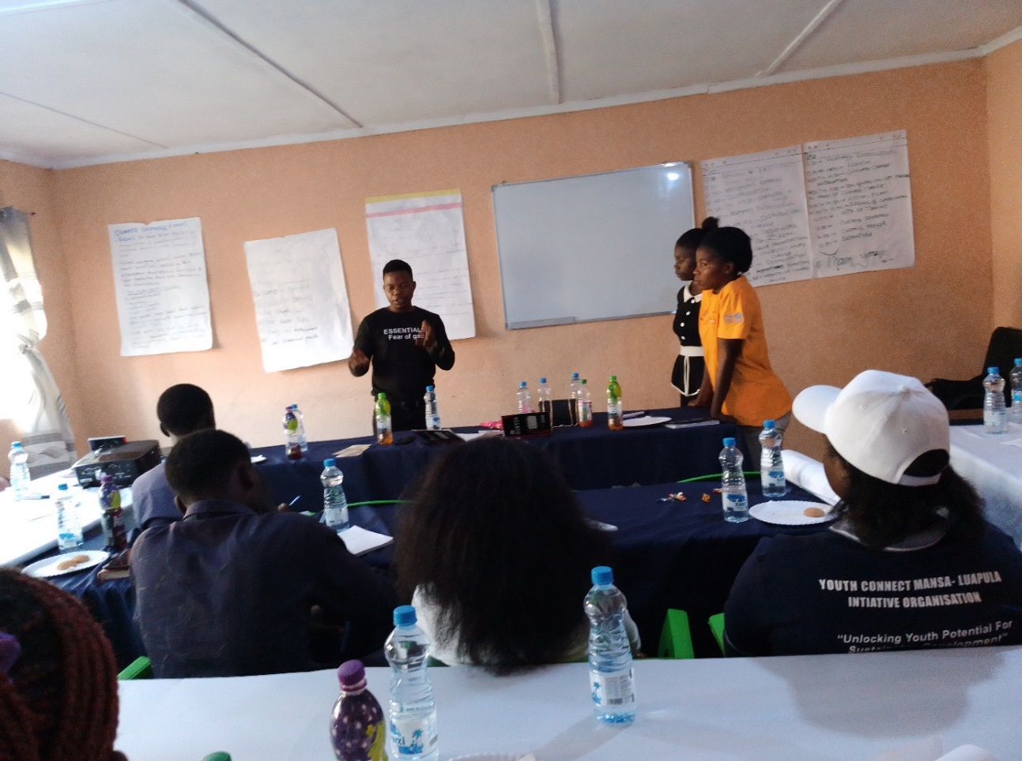Civil unrest

***Group two making their presentation***

***Reactions / Contributions from Participants:***

Mr Jones made his contribution by stating that, “We must educate people on sustainable development, which means meeting our current needs without compromising the ability of future generations to meet their own needs. In the past, we’ve seen the consequences of mismanaging our resources, often due to following harmful examples. However, we have the power to rewrite the blueprint and change our ways.

Let’s take proactive steps to adopt sustainable practices, using resources responsibly and prioritizing the well-being of future generations. By setting a positive example, we can inspire them to build upon our efforts and strive for even greater sustainability.”

Mr Mapani chipped in by stating that, “As humans we face significant health risks due to global warming. Our bodies are adapted to function optimally within a narrow temperature range, with a normal body temperature between 35 and 370C. However, as temperatures rise, our enzymes can become denatures at 450C and destroyed at 600C, leading to severe health consequences. The escalating heat stress caused by global warming is already having devastating effects.

Water sources like swamps and rivers are drying up, displacing wildlife and leading to tragic consequences. For instance, elephants in the southern province are being forced to roam in search of water, resulting in fatalities and human casualties when they encounter people in their path. It’s crucial we address this crisis to protect our health, biodiversity and ecosystems.”

Mr Godfrey also made his contribution by stating that, “As journalists, we often discuss lifestyle choices, but what are we actually doing about climate change? Many of us are still struggling with basic practices like reusing items or opting for eco-friendly products. Our homes are overflowing with plastic bags from past shopping trips, and yet we continue to accumulate more plastic with each visit to the supermarket.

I recently covered a story that made me realize how much work needs to be done right here in Mansa. Our main water source, the Mansa River, is in poor condition, plagued by garbage and litter. When we witness someone littering, our usual response is to simply watch. We shouldn't let such behavior go unchecked; it starts with us. We need to prioritize caring for our planet and environment without waiting for external reminders. For instance, we shouldn't cut down trees indiscriminately.

At a recent Adventist camp meeting, a fire broke out, and although there were no fatalities, I was shocked to see a couple laughing and enjoying the destruction. When I questioned them, they dismissively said there was nothing they could do about it. This attitude is deeply concerning. The truth is, every small effort counts. If I'm driving and see someone throwing trash out of their car window, I take note of their number plate and report them to RTSA. Holding people accountable can make a significant difference.”

**Group Three - Impacts of Climate Change**

Group three started their presentation by defining the word impact and according to them, an impact is a strong effect or influence on a situation, thus the impacts of climate change include the following;

* Temperature changes
* Displacement of people
* Change in precipitation which causes an increase in the frequency, intensity, rising sea levels and change in rain patterns.
* Disease burden
* Nutrition issues – stunting,
* Loss of economic livelihood
* Gender and social related issues
* Underdevelopment
* Dependence syndrome

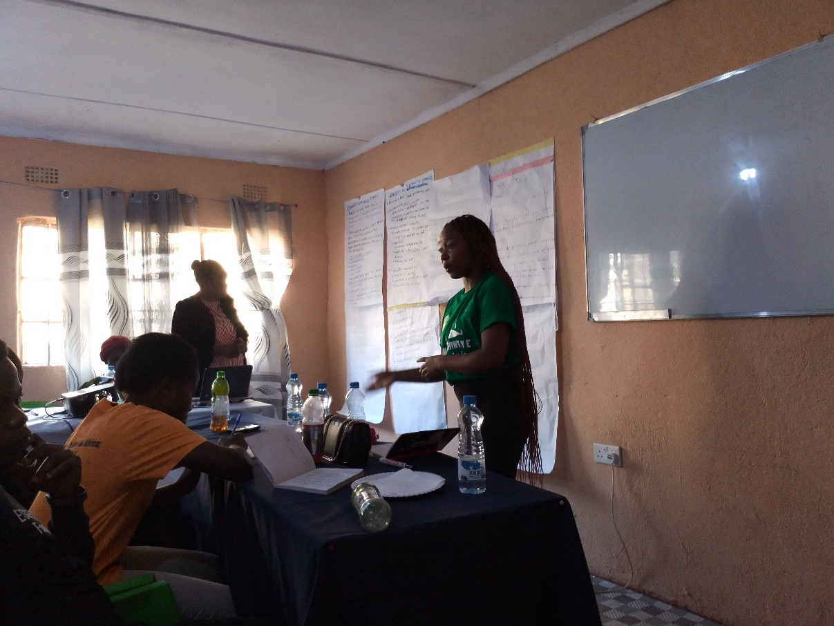**Group 4 – Preventing Climate Change**

***Group four making their presentation***

* Reduce Greenhouse gas emissions
* Protect and restore forests
* Promote sustainable development
* Individual action
* Adopt sustainable transportation
* Advocate for change
* Reduce energy use
* Sustainable harvesting and utilization
* EIA
* Foster policy changes that address climate change and promote sustainability
* Reduce, Reuse and Recycle (3 R’s)

**Group 5 – What We Can Do as Youths**

* Awareness raising
* Plant more trees and stop cutting indiscriminately
* Sustainable agriculture practices
* Encourage natural regeneration
* Promote community forest management
* Promote private nurseries / forests
* Conservation and sustainable utilization of existing forests
* Assisted regeneration
* Stop burning waste and indiscriminate throwing of garbage
* Adopt technologies that are sustainable and climate friendly

After recess, the youth came together to brainstorm an action plan and outline their expectations.

|  |  |  |  |  |
| --- | --- | --- | --- | --- |
| **ACTION PLAN** | | | | |
| **Objectives** | **Actions** | **Responsible Parties** | **Timeline** | **Resources** |
| To reduce the effects of climate change in communities | Conduct sensitizations in selected communities | Climate Change Champions | 10 – 14 September 2024 | Funds for banners, water, drinks and transport |
| To reduce incidences of early child marriages | Carry out sensitizations in schools and communities | Youths under Chandrika | By 30 September 2024 | Funds for banners, water, drinks and transport |

After a productive and engaging workshop on climate change, Chandrika WYF proudly presented participants with certificates of achievement, officially recognizing them as Climate Change Champions.

This milestone marked the successful completion of their journey, empowering them to make a positive impact and advocate for environmental sustainability in their communities.

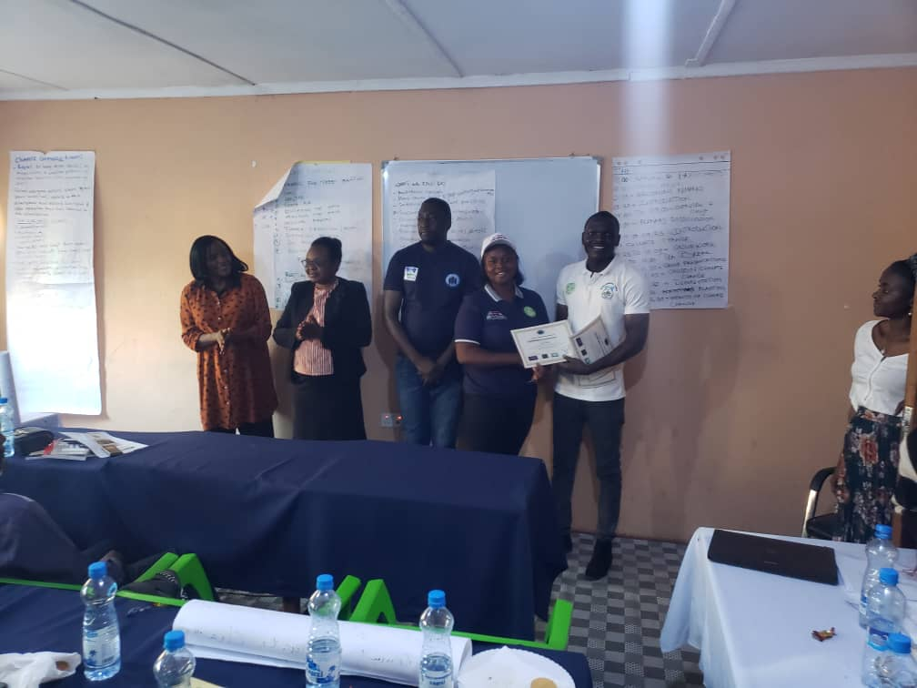***One of the participates receiving a certificate at the end of the workshop***

**Conclusion**

The workshop on climate change was a success and the awarding of certificates was the perfect finale. We look forward to fulfilling all that was suggested in the action plans and meeting all the expectations mentioned earlier. We are confident that the actions of the climate change champions will inspire others to join the fight against climate change, creating a ripple effect that will resonate globally.